**Uncertainty** refers to a lack of certainty or precise knowledge about something. It has situations where information is incomplete, imprecise, or subject to variability. Handling:-

1. *Fuzzy Logic:* It uses a scale from 0 to 1 to express degrees of truth. As it's not just "yes" or "no," it can sometimes be hard to understand.
2. *Probabilistic Reasoning:* Uses probabilities, like the chance of rain tomorrow, to make decisions (Bayesian methods). Handy with accurate data.
3. *Hidden Markov Models (HMMs):* Underlying states are hidden and observable outputs are known. Great for guessing what someone is saying in a noisy environment (speech recognition or bioinformatics).
4. *Certainty Factors and Qualitative Fuzzy Logics:* These ad hoc approaches blend fuzzy logic with certainty factors, like mixing different ways of thinking to make decisions. They can be flexible but harder to understand as they're not as clear-cut.
5. *Neural Networks:* Not built for uncertainty, but they can still figure out when something's not quite certain based on lots of examples. Might not always explain why they make a decision. They're like really smart pattern finders.

**Impreciseness** refers to a lack of exactness or specificity in language or data. It occurs when information or statements are vague, ambiguous, or lack precise definitions.

**Doorbell Problem:** The doorbell rang at midnight. Was someone there at the door?

Mohan was sleeping in the room. Did Mohan wake up when the doorbell rang?

*Proposition 1: AtDoor(x) → Doorbell*

*Deductive reasoning:* If p implies q, and q is true, then p must be true. If we hear doorbell ring (q), & it rings when someone presses button (p), then if q is true, it implies that p is true.

*Abductive reasoning*: If p implies q & we find q is true then we infer p. Consider different possibilities and select the most likely explanation. (Short Circuit, Wind, etc.)

*Proposition 2: Doorbell → Wake (Mohan)   
Deductive reasoning:* If it is always true, then if the doorbell rings, it logically implies that Mohan wakes up. This may not always be the case. Mohan could be tired or in a deep sleep.

*Abductive reasoning:* Mohan waking up might suggest that the doorbell rang, but there could be other reasons like a loud noise, an alarm clock, etc. for him waking up, from elsewhere.

**Diagnosis** always involves uncertainty.

Eg: Dental diagnosis: (toothache)

Toothache → Cavity  
It's wrong as not all people with toothaches have cavities. It may be due to other problems.

Toothache → Cavity V Gum Problem V Abscess…….

To complete the list, we have to add an almost unlimited list of possible problems

Cavity → Toothache

This is not also the right one. Not all cavities cause pain

**Sources of uncertainty:**

1. *Weak Implications:* Implications don't strongly support the conclusion.
2. *Imprecise Language:* Terms like "often," "rarely," and "sometimes" are imprecise and need to be quantified to reason effectively.
3. *Precise Info Complexity:* (due to antecedents or consequents) Makes reasoning difficult.
4. *Incomplete Knowledge:* Not all antecedents or consequents may be known or guessed.
5. *Conflicting Info:* Different sources or interpretations may provide conflicting information.
6. *Propagation of Uncertainties:* Uncertainties can propagate through chains of reasoning, leading to weaker beliefs in subsequent conclusions.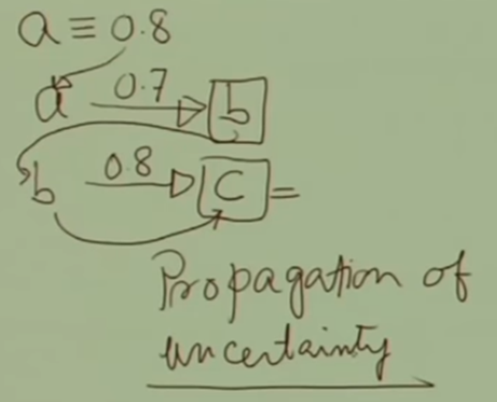

"a implies b" with a belief of 0.7, & "b implies c" with 0.6. If "a" is known with certainty of 0.8, the strength of belief in "b" inferred from "a" is weaker than 0.7. When "c" from "b," belief is even weaker due to propagation of uncertainty. Shows how uncertainty can increase in the absence of interdependencies in reasoning.

*Degrees of Belief:* **Probability Theory** Quantifies confidence in outcomes, managing uncertainty from incomplete knowledge and unforeseen events.

*Qualification Problem:* Helps handle various exceptions (e.g., car breakdowns, traffic) by summarizing uncertainties.

"P(cavity | toothache) = 0.8" : chance of a cavity if patient has a toothache, with limited info.

With more information: "P(cavity | toothache + history of gum disease) = 0.4" Gum disease also causes toothache, reducing the probability.

Comprehensive evidence: "P(cavity | E) = 0" Additional examination reduces the probability.

**Utility Theory** helps agents represent & reason with their preferences:

*Utility:* Usefulness or desirability of a state (higher preferred) for an agent.

Relative Utility: Utility is specific to the agent's perspective. Checkmating an opponent has high utility for the winner and low utility for the loser.

**Decision Theory** = Probability Theory + Utility Theory: Making rational decisions by considering both the likelihood of outcomes and their desirability.

*Maximum Expected Utility (MEU):* An agent is rational if it chooses the action that maximizes the expected utility, averaged over all possible outcomes.

*Steps for rational decision-making:*

1. List all potential actions.
2. Determine outcomes for each action.
3. Assess the probability of each outcome.
4. Evaluate the utility of each outcome.
5. Calculate the probability-weighted utility for each action.
6. Choose the action with the highest expected utility.

**Bayesian reasoning and probability** theory enable us to make informed decisions and conclude in uncertain environments by using probabilities and understanding dependencies among variables. Notations:-  
*RV:* Represents outcomes of a random experiment, with values varying with each trial.

*Sample Space (S):* Set all possible random variable outcomes. (e.g. Tossing coin: S={H, T})

*Atomic Event:* Complete specification of the uncertain state of the world (e.g., combinations of cavity and toothache, Cavity = False ∧ Toothache = True, etc).

*Sample Space (Ω):* Denoted by Ω, contains all possible worlds (ω) for a random variable.

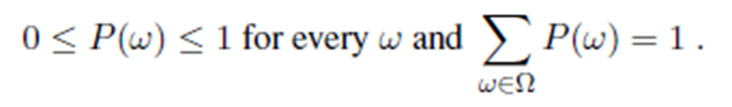They are called events, which are a subset of ω.

*Probability (P):* Measure of the likelihood of occurrence of a particular outcome or event.

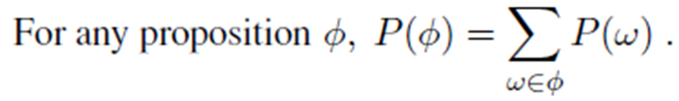

**Probabilistic Assertions and Queries:-**

*Events:* Sets of possible worlds or outcomes (e.g., sum of two dice being 11).

*Probability of Events:* Sum of probabilities of worlds where the proposition holds true.

Example: ϕ (Getting an Odd Number after Rolling the Dice):

Sample Space (S): {1, 2, 3, 4, 5, 6} Event (ϕ): {1, 3, 5}

Probability (P(Odd)): P(1) + P(3) + P(5) = 1/6 + 1/6 + 1/6 = 1/2

**Unconditional or Prior Probabilities** represent the degree of belief in a proposition without any additional evidence or information. P(Fever)=0.1 means the probability that a patient has a fever is 0.1, without considering any other information.

*Discrete Random Variables:* Finite number of distinct values. Fever, Doubles, Odd, Even.

Example: P(Cavity) (probability of having a cavity).

*Continuous Random Variables:* Infinite number of distinct values.

Example: P(Temp=x) = Uniform[18C,26C] (x)

**Conditional probability**, denoted as P(A∣B), represents the probability of event A occurring given that event B has occurred. This accounts for additional information.

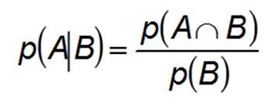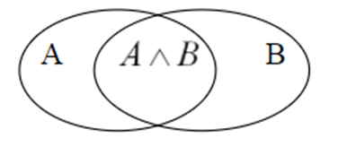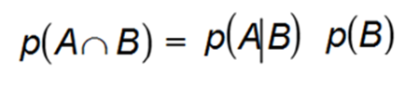

Kolmogorov’s axioms provide rules for probability theory:

1. 0 ≤ P(A) ≤ 1
2. ( P(true) = 1 and P(false) = 0)
3. P(A ∨ B) = P(A) + P(B) - P(A ∧ B)

Derived properties include:

1. The complement rule. P(¬A)=1−P(A) and P(A)=1−P(¬A).
2. Probability sum for mutually exclusive events. P(A∨B)=P(A)+P(B)
3. The sum of probabilities of atomic events where a proposition holds.

Bayes' Rule: probability of an event A based on new evidence B. Combines prior knowledge with new data, making it a powerful tool for probabilistic reasoning & decision-making.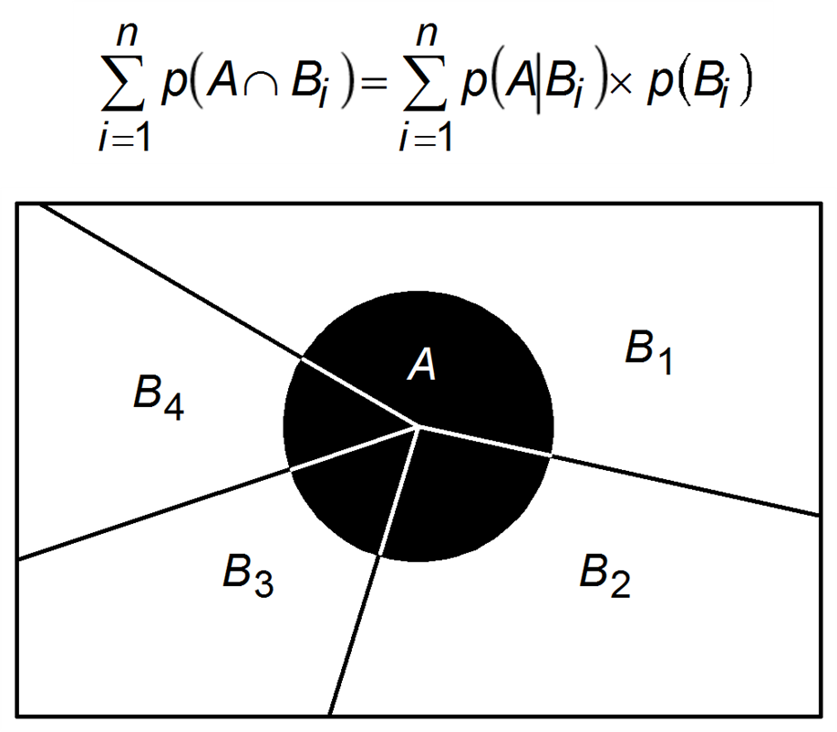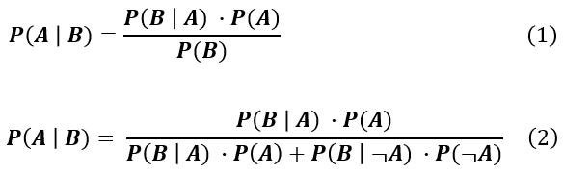

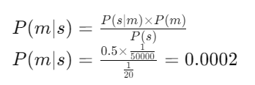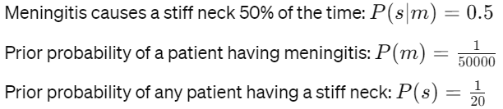

1 in 5000 patients with a stiff neck might have meningitis.

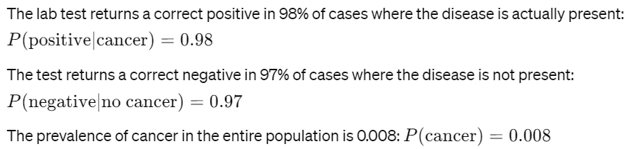

Using direct causal or model-based knowledge, such as P(s∣m), provides robustness in probabilistic systems. While statistical observations might need updates during epidemics, causal information remains reliable.

Joint probability distribution assigns probabilities to all possible atomic events. 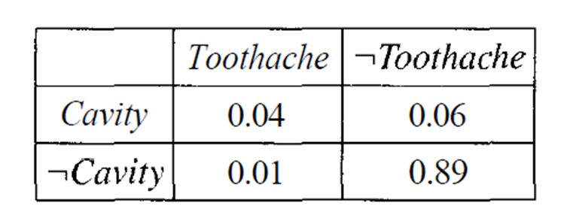

P(¬Cavity)=0.01+0.89=0.9 P(Toothache)=0.04+0.01=0.05

P(¬Toothache)=0.06+0.89=0.95



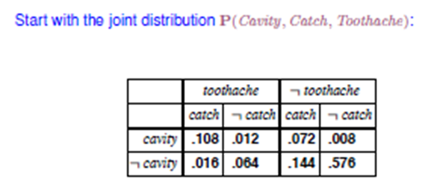

P(Toothache)=0.108+0.012+0.016+0.064=0.2

P(C V T)=0.108+0.012+0.072+0.008+0.016+0.064=0.28

P(cavity|toothache)= P(cavity^ Toothache)/ P(Toothache)

= (0.108+0.012)/(0.108+0.012+0.016+0.064) = 0.6

P(cavity|toothache)+P(~ cavity|toothache) =0.6 + 0.4=1

1/P(toothache) remains constant (**normalization constant**) no matter any value of cavity. 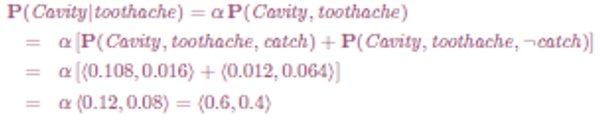

A and B are independent if:-

P(A|B)=P(A) P(B|A)=P(B)  
P(A,B)=P(A) P(B)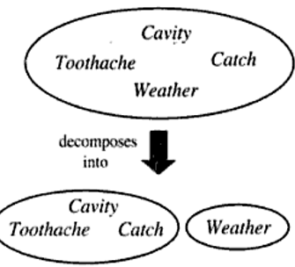

Variable represented for probability are P( Weather, toothache , catch , cavity)

It can be deduced as P(weather= cloudy) P(toothache ,catch ,cavity)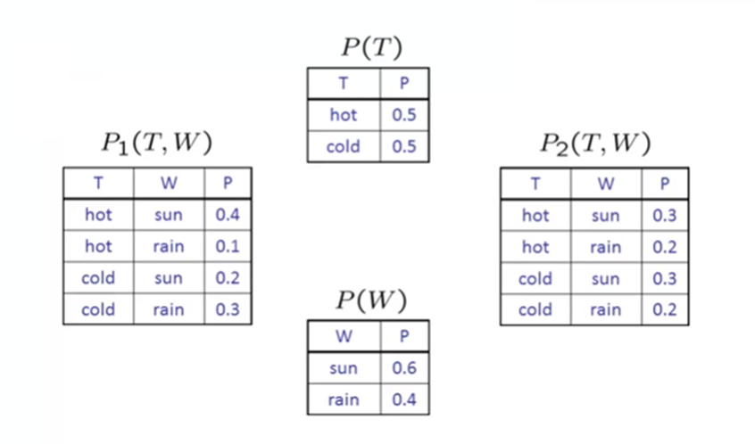

Even Coin flips are independent.



To verify Independence, build marginals for each 

Variables: P(T) and P(W).

Calculate another distribution P2(T,W) as P(T)*P(W)

If P1(T,W)= P2(T,W)… T and W are independent

**Conditional Independence:** basic & robust knowledge form, abt uncertain environments.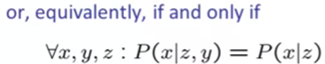

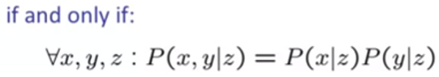

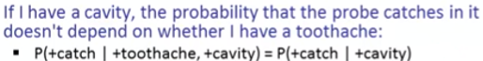

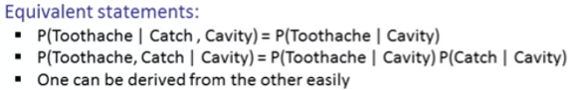



There are around 2^3-1=7 independent entries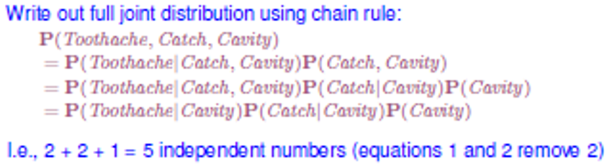

Chain Rule: P(X1, X2, …. Xn)=P(X1) P(X2|X1) P(X3|X1,X2)

Trivial decomposition: P(Traffic,Rain,Umbrella)= P(R) P(T|R) P(U|R,T)

With Conditional Independence: P(Traffic,Rain,Umbrella)= P(R) P(T|R) P(U|R)

**Bayesian networks**, also known as graphical models, offer a method for representing intricate joint distributions by employing straightforward, localized distributions, typically in the form of conditional probabilities. Bayesian networks applications:

1. *Medical Diagnosis:* Diagnosing diseases based on symptoms and medical history.
2. *Risk Assessment:* Analyzing and managing risks in finance, insurance, & projects.
3. *Predictive Modeling:* Forecasting weather, stock market trends, & customer behavior.
4. *Genetics and Bioinformatics:* Modeling gene interactions and disease pathways.
5. *Natural Language Processing:* Analyzing in speech recognition and translation.
6. *Fault Diagnosis:* Identifying faults in complex systems like machinery and electronics.
7. *Fraud Detection:* Detecting suspicious activities in banking transactions.
8. *Cybersecurity:* Detecting anomalies in network traffic and malware analysis.
9. *Decision Support Systems:* Providing probabilistic assessments for decision making.

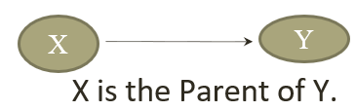

Dependencies among variables represented using a directed graph structure.

Node: random variable, and Links: dependencies.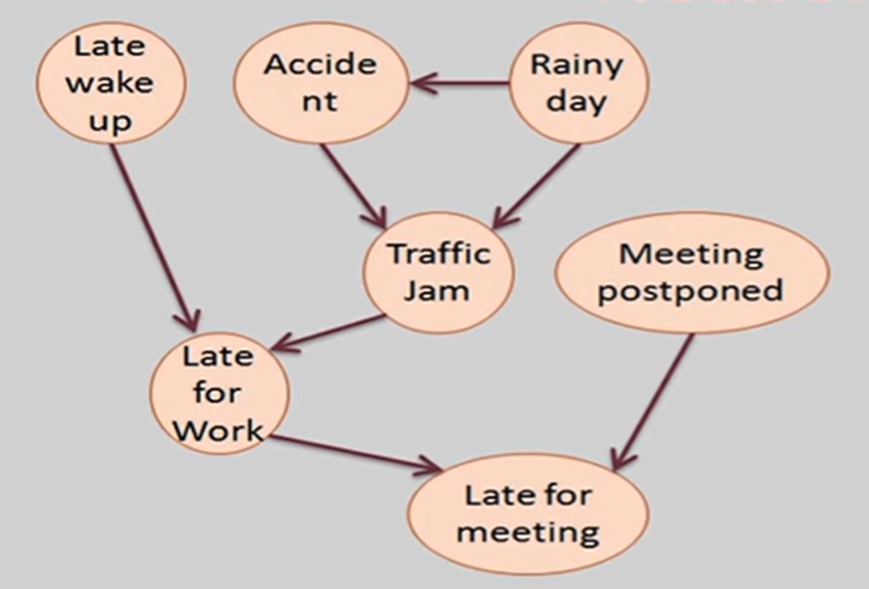

To understand, we see the network as a 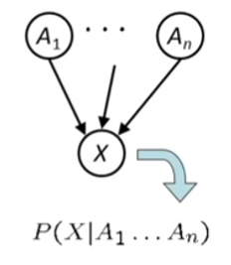

representation of the joint probability

Distribution and view it as an encoding

of a collection of conditional

independence statements.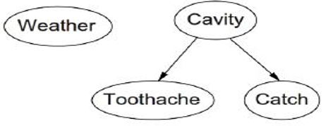

*Bayes Net=*

*Topology (graph) +*

*Local Conditional Probabilities*

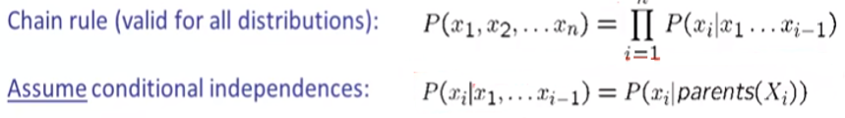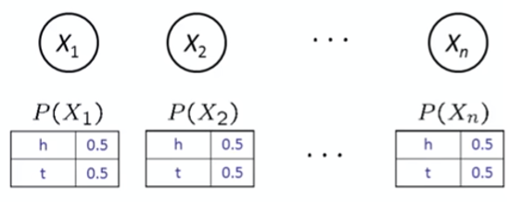

Example: Coin Flip: 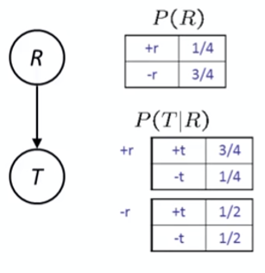

Example: Causal Direction Traffic:



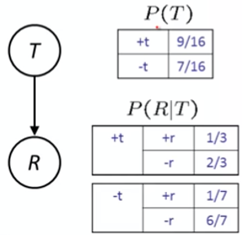

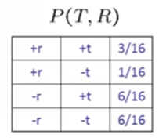

Example: Reverse Causality Traffic:

Example: Burglar Alarm:-

Probability that alarm has sounded but

neither burglary nor earthquake has 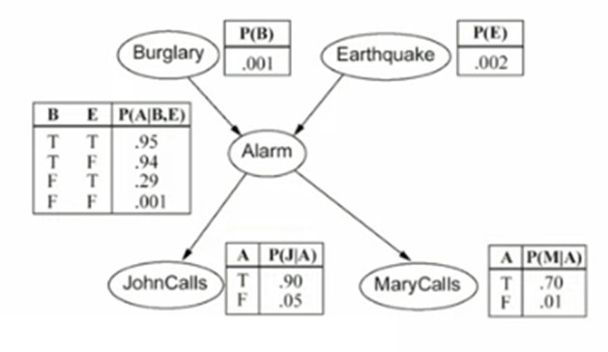

occurred, & both John & Mry call?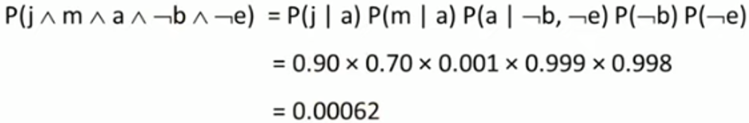

What is the probability that John Calls?

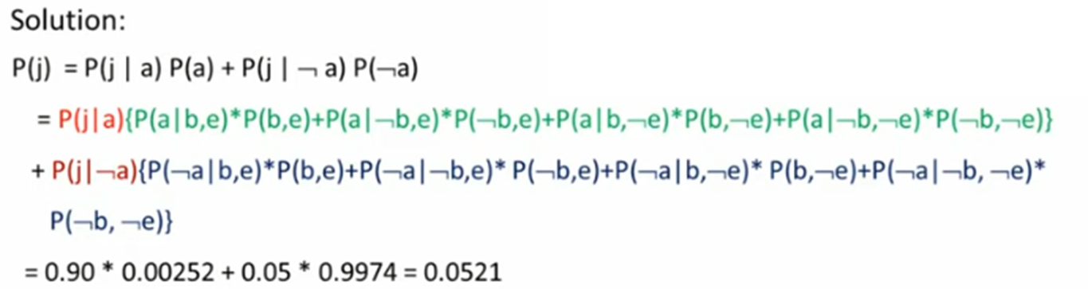

**Inference in Bayesian networks** involves determining probability distribution of certain variables (query nodes) based on known probabilities of other variables (evidence nodes).

**Exact Inference:**

1. *Enumeration:* Systematically sums over the probabilities of all possible scenarios.
2. *Variable Elimination:* Eliminates variables by summing over their probabilities, simplifying the network step-by-step.

**Approximate Inference:**

1. *Monte Carlo Methods:* Uses random sampling to estimate probabilities, making it feasible for large and complex networks.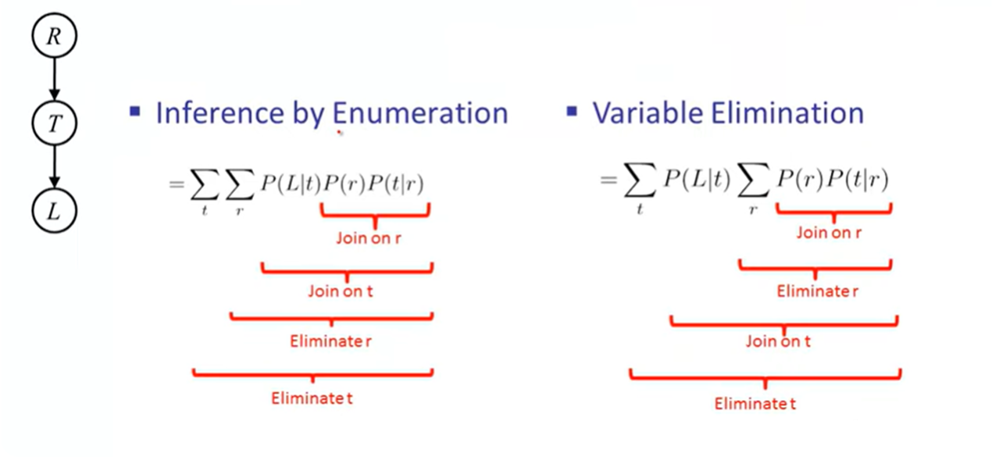



L: Late for work

